Project Design Phase-II
Technology Stack (Architecture & Stack)

Date | 09 September 2026
Team ID | SWUID2026190415
Project Name | Medical Diagnosis Center by Service Portal (ServiceNow)
Maximum Marks | 4 Marks

Technical Architecture:
The Medical Diagnosis Center by Service Portal is developed on the ServiceNow Platform using a 3-tier architecture. Patients interact with the Service Portal to register, book diagnostic tests, make payments, and download reports. ServiceNow processes the requests through Business Rules, Flow Designer, Notifications, and Script Includes. All patient, appointment, report, and payment data is stored securely in ServiceNow database tables

Architecture Diagram

.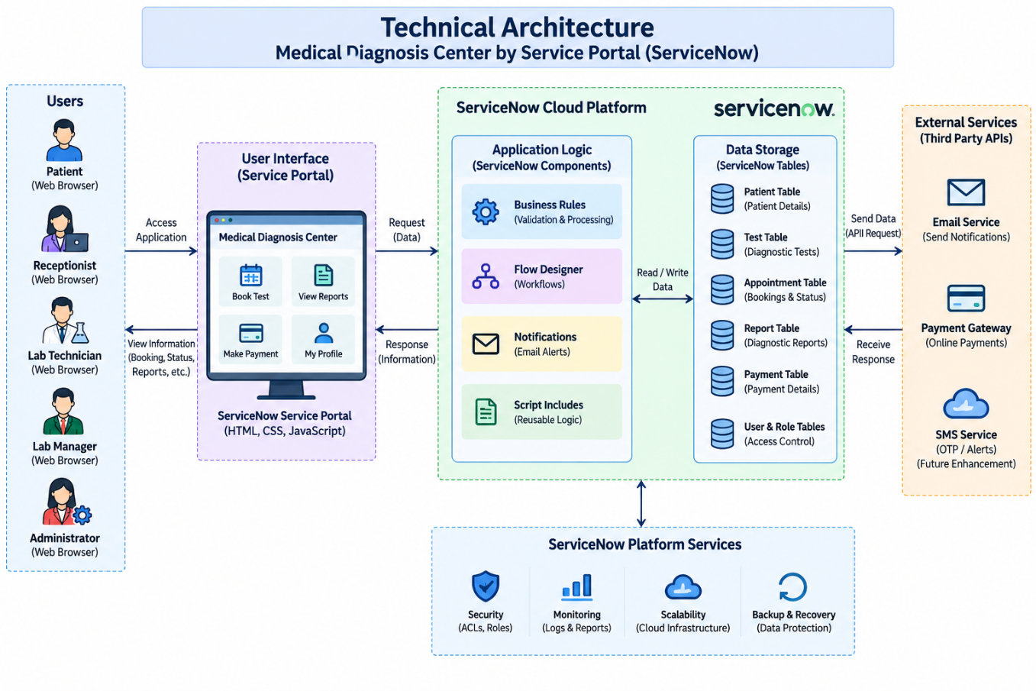

Table-1 : Components & Technologies:
S.No | Component | Description | Technology
 | User Interface | Patients and staff interact with the application through the Medical Diagnosis Center Service Portal. | ServiceNow Service Portal, HTML, CSS, JavaScript / Angular Js / React Js etc.
 | Application Logic- Appointment Management | Handles patient registration, appointment booking, slot validation, and booking rules. | Business Rules, Client Scripts, Script Includes
 | Application Logic- Workflow Automation | Manages appointment lifecycle, approval workflow, report processing, and notifications. | Flow Designer, Notifications, Email Templates
 | Application Logic- Payment Management | Calculates fees, tracks payment status, generates invoices, and manages refunds. | Business Rules, Flow Designer, Currency Fields
 | Database | Stores patient details, diagnostic tests, appointments, reports, and payment information. | ServiceNow Custom Tables (Scoped Application)
 | Cloud Database | Centralized storage for all records within the ServiceNow platform. | ServiceNow Cloud Database
 | File Storage | Stores uploaded diagnostic reports and related documents securely. | IBM Block Storage or Other Storage Service or Local Filesystem
 | External API- Email Service | Sends booking confirmation, payment confirmation, approval, and report availability emails. | ServiceNow Attachments
 | External API- Payment Integration | Supports secure online payment processing and invoice generation. | Payment Gateway Integration (Future Phase)
 | Machine Learning Model | Not used in the current project implementation. | Not Applicable (N/A)
 | Infrastructure (Server / Cloud) | Deploys the application on the ServiceNow cloud platform. | ServiceNow Cloud Platform (Scoped Application)

Table-2: Application Characteristics:
S.No | Characteristics | Description | Technology
 | Open-Source Frameworks | Frontend widgets and portal pages are customized using ServiceNow web technologies. | HTML, CSS, JavaScript, Service Portal Widgets
 | Security Implementations | Protects patient records using login authentication, ACLs, role-based access control, and secure permissions. | ACLs, Roles, ServiceNow Authentication, RBAC
 | Scalable Architecture | The application supports adding more patients, diagnostic tests, appointments, reports, and users without changing the overall architecture. | Scoped Application, ServiceNow Cloud Architecture
 | Availability | The Service Portal is available online for patients and hospital staff anytime through the ServiceNow cloud platform. | ServiceNow Cloud Infrastructure
 | Performance | Real-time slot validation, optimized business rules, and Flow Designer automation provide faster appointment processing and report updates. | Business Rules, Flow Designer, ServiceNow Database

References:
https://c4model.com/
https://developer.ibm.com/patterns/online-order-processing-system-during-pandemic/
https://www.ibm.com/cloud/architecture
https://aws.amazon.com/architecture
https://medium.com/the-internal-startup/how-to-draw-useful-technical-architecture-diagrams-2d20c9fda90d

